**Action Plan Tool**

**How to Use**

**GOAL** Create goals for adulthood on your Individualized Education Program (IEP), Person Centered Plan, or using another Goal Planning Tool.

**PLAN** Customize your [action plan](https://worktogethernc.com/action-plans/) for topic area(s) of interest, based on your goals. Make a plan for when each item will be completed, by whom, and using which resources or services.

**DO** Begin taking action on your chosen action plan items! Remember to block out time to complete them.

**CHECK** Monitor your progress using our Action Plan Monitoring chart. It’s OK for plans to change! Adjust, or re-create, your Action Plan, as needed.

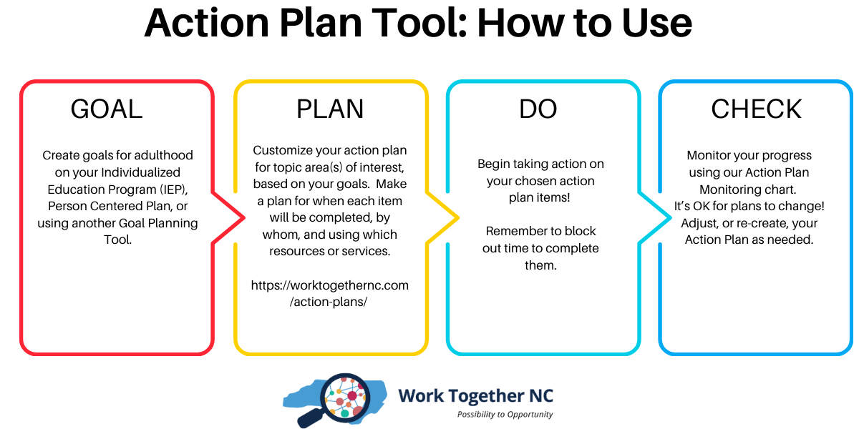

**Action Plan Monitoring Chart**

Action plan topic (select):

* Employment
* Postsecondary education
* Housing & Community Living
* Healthcare
* Adult services
* Financial well-being
* Transportation
* IEP
* Self-determination / Self-advocacy
* Supported Decision Making

|  |  |  |  |  |
| --- | --- | --- | --- | --- |
| Action item | By when | Who’s responsible? | Resources or services I/we plan to use: | Status |
|  |  |  |  | * Not yet**🕓** * In progress🔃 * Done✅ |
|  |  |  |  | * Not yet**🕓** * In progress🔃 * Done✅ |
|  |  |  |  | * Not yet**🕓** * In progress🔃 * Done✅ |
|  |  |  |  | * Not yet**🕓** * In progress🔃 * Done✅ |
|  |  |  |  | * Not yet**🕓** * In progress🔃 * Done✅ |
|  |  |  |  | * Not yet**🕓** * In progress🔃 * Done✅ |
|  |  |  |  | * Not yet**🕓** * In progress🔃 * Done✅ |

**Having trouble completing an Action Item?**

**Use this chart!**

🤔 What stopped you or your team from completing an action item?

Check your answer below!

Recreate your [action plan](https://worktogethernc.com/action-plans/)

Check out Work Together NC’s [service library](https://worktogethernc.com/services/).

Check out Work Together NC’s [resource library](https://worktogethernc.com/resources/) and [toolkits](https://worktogethernc.com/toolkits/).

Break the item down into smaller steps

Set a new time in the “By when” column

Remember to block out the new time in your planner or calendar

🤔 What stopped you or your team from completing an action item?

My goal has changed.

I/ we need more help

I/ we need more information or skills

Something came up

Not enough time

Too big or too hard